General user guide

After you have installed the .exe you can begin searching for either a single person’s property records, or a group of peoples’ property records. To search for a single person's property records simply click Individual Search. To search for a group of peoples’ property records click Group Search.

Individual Search

After clicking Individual Search, you will be taken to the screen show above where you can type a name written as “first name” “last name”. Then you can click continue to move onto the next page.

Group Search

After clicking on Group Search you will be taken to the above page where you can drag an Excel file with a list of names from your files into the dotted box to upload. Then you click upload now to upload to file to the program and continue to the next page.

Excel file format

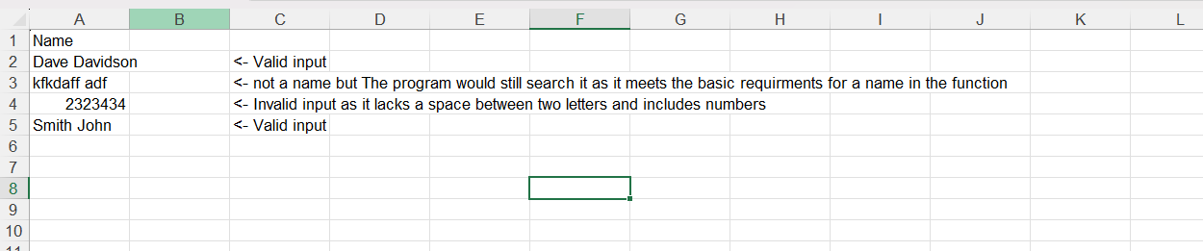

Above is the necessary format the excel file needs to have with the value ‘Name’ in column A and a person or person’s full name under the value ‘Name’ with a space in-between. You can only have one name in each row with no middle name only ‘First Last name’. However, there is no limit to the number of names you can put under column A.

County Selection

After you have typed a single person’s name or uploaded an Excel file you will be taken to the above page where you can select one or all counties to search in. To do so click the box to the left of the county’s name to check it for searching. Then once you have checked all the counties you need you can click continue to have the program run the search.

Important notes while the program runs

Do not use the keyboard or mouse while the program is running as this may mess up the search. Most antivirus will flag this program as suspicious so you may need to tell your antivirus to allow the program to run for each program if it tries to stop the program. The program should only take anywhere from 5 to 10 minutes to run if it takes any longer than 15 minutes then close the program and try again, although this may vary on your internet connection.

Search Results

After clicking continue you will arrive on the above page where you can click any of the files to download the Microsoft Excel file which contains the results of your search for that list of records.

After you click a county, you will be asked to name the file and save it into a folder of your choosing. Note that the file must end in .xlsx for it to be downloaded to your computer correctly. Once you do that all you need to do is open your newly created Excel file and you will be given the results of your search. The results will be divided into columns with names such as Address and a list of addresses for each name you input. If no data is turned up for a name, then NULL will be displayed instead of any data relating to that name.